SIMATS ENGINEERING
ASSESSMENT TOOL 2
COURSE NAME: Cryptography and Network Security
COURSE CODE: CS A5113
NAME: Basavaiah Lavanya
REG:NO:1923720046

CONCEPT MAPPING
1. Create a concept map linking the following: Security Attacks, Threats, Risks and Security Goals
(Confidentiality, Integrity, Availability. Perform the following tasks:
a. Show how each attack leads to specific threats and risks
b. Map how security goals help mitigate them Provide one real-world example for each link
2. Develop a concept map comparing substitution techniques: Caesar Cipher, Monoalphabetic Cipher, Vigenère
Cipher and Hill Cipher. Perform the following tasks to connect based on: Key usage, Complexity and Security
strength. Analyze which technique is most secure and why.
3. Construct a concept map for Classical Encryption Schemes: Substitution Techniques and
Transposition Techniques. Perform the following tasks:
a. Show differences and similarities
i.Map how each affects the Data structure and Security level
ii.Analyze which is more vulnerable to attacks and why
4. Create a concept map connecting Steganography concepts: Data Hiding, Watermarking and
Survivability. Perform the following tasks:
a. Show relationships between these concepts
b. Analyze how each contributes to secure communication
c. Include one real-world application for each
5. Draw a concept map linking number theory concepts used in cryptography: Modular Inverse, Extended Euclid
Algorithm, Fermat’s Little Theorem, Euler’s Phi Function and Euler’s Theorem. Perform the following tasks:
a. Show how each concept is mathematically connected
b. Map their role in encryption/decryption
c. Analyze which concept is most critical for public key cryptography and justify

Question 1
Concept Map Linking Security Attacks, Threats, Risks and Security Goals (Confidentiality, Integrity, Availability)
Introduction
Information security is the practice of protecting information systems from unauthorized access, misuse, modification, destruction, or disruption. Every organization faces different types of security attacks that exploit vulnerabilities and create threats, which in turn introduce risks to valuable assets. To reduce these risks, organizations implement security goals, commonly known as the CIA Triad:
**Confidentiality**
**Integrity**
**Availability**
Understanding the relationship between attacks, threats, risks, and security goals is essential for designing secure computer systems.
Concept Map
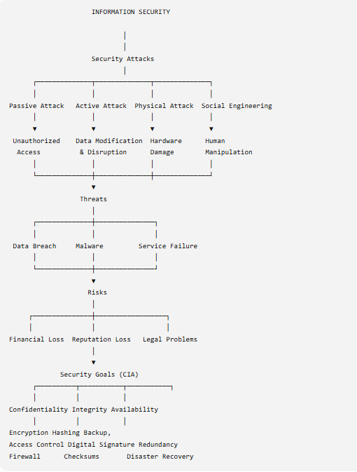

Relationship between Security Components
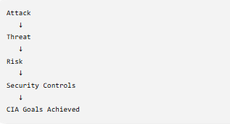
Understanding Each Component
1. Security Attack
A security attack is any action that attempts to compromise the confidentiality, integrity, or availability of a computer system.
It may be intentional or accidental.
Types of Security Attacks
1. Passive Attack
Passive attacks only observe information without changing it.
Examples:
* Packet sniffing
* Eavesdropping
* Traffic analysis
Characteristics
* Difficult to detect
* No data modification
* Mainly affects confidentiality

### 2. Active Attack
Active attacks modify or destroy information.
Examples
* Virus
* Ransomware
* Data modification
* Denial of Service
Characteristics
* Easy to detect
* Difficult to recover
* Affects integrity and availability

### 3. Physical Attack
Physical attacks damage computer hardware.
Examples
* Theft of laptops
* Server destruction
* Fire
* Flood

### 4. Social Engineering Attack
These attacks manipulate humans.
Examples
* Phishing
* Fake emails
* Phone scams
* Shoulder surfing

# 2. Threat
A threat is a possible danger that can exploit a vulnerability.
Threats originate from attacks.
Examples include
* Malware
* Hackers
* Natural disasters
* Insider attacks

## Types of Threats
### External Threats
Coming from outside the organization.

Examples
* Hackers
* Cyber criminals
* Terrorists

### Internal Threats
Coming from employees.
Examples
* Data theft
* Negligence
* Misconfiguration
### Environmental Threats
Examples
* Earthquakes
* Floods
* Fire
* Power failure
# 3. Risk
Risk is the possibility of suffering damage when a threat exploits a vulnerability.
Formula
Risk = Threat × Vulnerability × Impact

Types of Risks
### Financial Risk
Loss of money due to attacks.
Example
Ransomware locking company files.
### Operational Risk
Business operations stop.
Example
Website becomes unavailable.

### Legal Risk
Violation of laws.
Example
Customer data leakage.
### Reputation Risk
Loss of customer trust.
Example
Facebook data breach.
# 4. Security Goals (CIA Triad)
# Confidentiality
Definition
Confidentiality ensures that information is accessible only to authorized users.

Methods
* Encryption
* Passwords
* Authentication
* VPN
* Access Control
Example
Online banking passwords remain private.

# Integrity
Definition
Integrity ensures that information remains accurate and unchanged.
Methods
* Hash Functions
* Digital Signatures
* Checksums
* Version Control
Example
Marks stored in a university database cannot be altered by students.

# Availability
Definition
Availability ensures systems remain accessible whenever needed.
Methods
* Backups
* UPS
* Load balancing
* Redundant servers
* Disaster recovery
Example
Google services remain available 24×7.

# (a) Show How Each Attack Leads to Specific Threats and Risks

Attack | Threat | Risk | Security Goal
Phishing | Credential theft | Bank account compromise | Confidentiality
SQL Injection | Database manipulation | Data corruption | Integrity
Ransomware | File encryption | Financial loss | Availability
DoS Attack | Network congestion | Service outage | Availability
Virus | File modification | Data loss | Integrity
Spyware | Information leakage | Identity theft | Confidentiality
Password Guessing | Unauthorized access | Confidential information exposed | Confidentiality
Insider Attack | Data manipulation | Reputation damage | Integrity
Server Theft | Loss of hardware | Business interruption | Availability
Malware | System compromise | Operational failure | CIA Triad

---

# (b) Mapping Security Goals to Mitigate Risks
Phishing
↓
Credential Theft
↓
Confidentiality
↓
Multi-factor Authentication
---------------------------------
Virus
↓
File Corruption
↓
Integrity
↓
Hash Functions
---------------------------------
DDoS
↓
Service Unavailable
↓
Availability
↓
Load Balancer
---------------------------------
Ransomware
↓
Encrypted Files
↓
Availability
↓
Regular Backups

# Real-World Examples for Every Link

### Attack → Threat
Attack
Phishing Email
↓
Threat
Password Theft
Real-world example
Employees receive fake Microsoft login emails that steal Office 365 credentials.
Attack
SQL Injection
↓

Threat
Database Compromise
Example
Hackers manipulate website databases to retrieve confidential customer records.
Attack

DDoS

↓
Threat
Network Congestion
Example
A shopping website becomes inaccessible during festive sales due to a DDoS attack.
Attack
Ransomware

↓

Threat
Data Encryption
Example
The WannaCry ransomware encrypted files on thousands of computers worldwide.
Threat → Risk
Threat
Credential Theft
↓

Risk

Financial Fraud

Example
An attacker transfers money from a victim's online banking account.
Threat
Malware Infection
↓
Risk
Loss of Business Operations

Example
Company employees cannot access important files for several days.
Threat
Database Corruption
↓
Risk
Incorrect Financial Reports
Example
Modified accounting records lead to inaccurate financial statements.
Threat
Power Failure
↓
Risk
Server Downtime
Example
Hospital management systems become temporarily unavailable during a blackout.

Risk → Security Goal
Risk
Identity Theft
↓

Goal
Confidentiality
Solution
Encryption, MFA, strong passwords.
Risk
Data Modification
↓

Goal
Integrity
Solution
Digital signatures, hash algorithms, audit logs.
---
Risk
Service Downtime
↓

Goal
Availability
Solution
Backups, redundant servers, disaster recovery plans.

# Complete Attack-to-Protection Flow
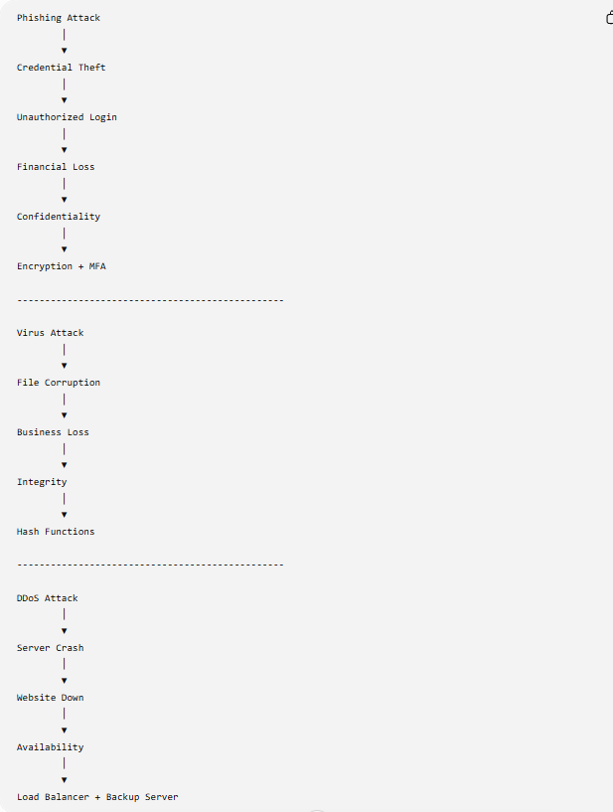
# Summary Table

Component | Description | Example | Security Goal
Security Attack | Attempts to exploit vulnerabilities | Phishing | CIA
Threat | Potential danger | Malware | CIA
Risk | Possible loss or damage | Financial loss | CIA
Confidentiality | Protects privacy | Encryption | Prevents data disclosure
Integrity | Protects accuracy | Hashing | Prevents modification
Availability | Ensures accessibility | Backup servers | Prevents downtime

# Advantages of Implementing Security Goals
* Protects sensitive information from unauthorized users.
* Maintains the accuracy and trustworthiness of data.
* Ensures continuous access to services and systems.
* Reduces financial losses caused by cyberattacks.
* Improves customer trust and organizational reputation.
* Helps organizations comply with legal and regulatory requirements.

Question 2
Concept Map Comparing Substitution Techniques: Caesar Cipher, Monoalphabetic Cipher, Vigenère Cipher and Hill Cipher
Introduction
Substitution ciphers are classical encryption techniques in which each letter of the plaintext is replaced with another letter according to a specific rule or key. The four common substitution techniques are Caesar Cipher, Monoalphabetic Cipher, Vigenère Cipher, and Hill Cipher. They differ in key usage, complexity, and level of security.

Concept Map
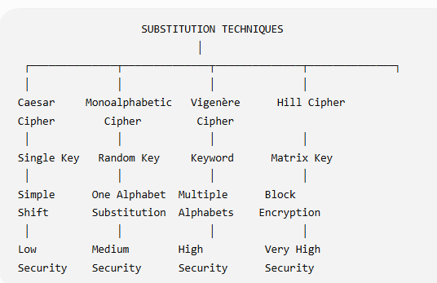
1. Caesar Cipher
Definition
The Caesar Cipher is the simplest substitution cipher in which each letter is shifted by a fixed number of positions in the alphabet.
Example
Plaintext: HELLO
Key = 3
Ciphertext: KHOOR
Key Usage
- Uses a single numeric key (1–25).
- Same key is used for the entire message.
Complexity
- Very simple.
- Easy to implement.
Security Strength
- Weak security.
- Easily broken using brute force or frequency analysis.
Advantages
- Easy to understand.
- Fast encryption and decryption.
Disadvantages
- Very small key space.
- Not suitable for secure communication.

2. Monoalphabetic Cipher
Definition
Each plaintext letter is replaced by another unique letter using a randomly arranged alphabet.
Example
Plain Alphabet : ABCDEFGHIJKLMNOPQRSTUVWXYZ
Cipher Alphabet: QWERTYUIOPASDFGHJKLZXCVBNM
Plaintext: HELLO
Ciphertext: ITSSG
Key Usage
- Uses a complete substitution alphabet as the key.
- One substitution rule is used throughout the message.
Complexity
- More complex than Caesar Cipher.
Security Strength
- Moderate security.
- Vulnerable to frequency analysis.
Advantages
- Large number of possible keys.
- Better security than Caesar Cipher.
Disadvantages
- Letter frequencies remain unchanged.
- Can be broken with statistical analysis.

3. Vigenère Cipher
Definition
The Vigenère Cipher is a polyalphabetic substitution cipher that uses a keyword to encrypt the plaintext.
Example
Plaintext: ATTACKATDAWN
Keyword: LEMON
Ciphertext: LXFOPVEFRNHR
Key Usage
- Uses a keyword.
- The keyword repeats until it matches the plaintext length.
Complexity
- Moderate.
- More difficult than Caesar and Monoalphabetic ciphers.
Security Strength
- High security among classical ciphers.
- Resistant to simple frequency analysis.
Advantages
- Uses multiple substitution alphabets.
- More secure than monoalphabetic techniques.
Disadvantages
- Repeated keywords can reveal patterns.
- Can be broken using Kasiski Examination.

4. Hill Cipher
Definition
Hill Cipher encrypts blocks of letters using matrix multiplication and modular arithmetic.
Example
Key Matrix:
|3 3|
|2 5|
Plaintext:
HI
Ciphertext:
TC
Key Usage
- Uses an invertible matrix as the key.
- Encrypts multiple letters at a time.
Complexity
- High.
- Requires knowledge of matrix operations.
Security Strength
- Highest among classical substitution techniques.
- Difficult to break using frequency analysis.
Advantages
- Encrypts blocks instead of individual letters.
- Strong mathematical security.
- Large key space.
Disadvantages
- Matrix calculations are complex.
- Requires an invertible key matrix.

Comparison Based on Key Usage
Technique | Key Used
Caesar Cipher | Single numeric key
Monoalphabetic Cipher | Random substitution alphabet
Vigenère Cipher | Keyword
Hill Cipher | Matrix key

Comparison Based on Complexity
Technique | Complexity
Caesar Cipher | Very Low
Monoalphabetic Cipher | Low
Vigenère Cipher | Medium
Hill Cipher | High

Comparison Based on Security Strength
Technique | Security Level
Caesar Cipher | Low
Monoalphabetic Cipher | Medium
Vigenère Cipher | High
Hill Cipher | Very High

Security Strength Concept Map
Weak
│
Caesar Cipher
│
Monoalphabetic Cipher
│
Vigenère Cipher
│
Hill Cipher
│
Strongest

Real-World Applications
Technique | Application
Caesar Cipher | Educational examples and puzzles
Monoalphabetic Cipher | Historical military communication
Vigenère Cipher | Historical diplomatic messages
Hill Cipher | Learning matrix-based cryptography

Analysis: Which Technique is Most Secure?
Among the four techniques, Hill Cipher is the most secure because:
- It encrypts blocks of letters instead of one letter at a time.
- It uses matrix multiplication, making encryption more complex.
- It is more resistant to frequency analysis.
- It has a larger key space compared to the other techniques.
- A change in one plaintext letter affects multiple ciphertext letters, increasing security.
Although Hill Cipher is the strongest classical substitution cipher, modern cryptographic algorithms such as AES and RSA provide much stronger security for real-world applications.

Summary Table
Feature | Caesar | Monoalphabetic | Vigenère | Hill
Key | Number | Alphabet | Keyword | Matrix
Complexity | Low | Medium | Medium | High
Security | Low | Medium | High | Very High
Main Weakness | Brute Force | Frequency Analysis | Repeated Key | Complex Implementation

Conclusion
Substitution techniques replace plaintext characters with ciphertext characters using different key mechanisms. Caesar Cipher is the simplest and least secure, while Monoalphabetic Cipher improves security through random substitution. Vigenère Cipher increases protection by using multiple substitution alphabets controlled by a keyword. Hill Cipher provides the highest security among these classical techniques due to its matrix-based block encryption and resistance to frequency analysis, making it the most secure classical substitution cipher.

Question 3
Concept Map for Classical Encryption Schemes: Substitution Techniques and Transposition Techniques
Tasks
- Show differences and similarities.
- Map how each affects data structure and security level.
- Analyze which technique is more vulnerable to attacks and why.
Introduction
Classical encryption techniques are divided into Substitution Techniques and Transposition Techniques. Both methods convert plaintext into ciphertext to provide confidentiality, but they use different approaches.
- Substitution Technique: Replaces each character with another character.
- Transposition Technique: Rearranges the positions of characters without changing them.

Concept Map
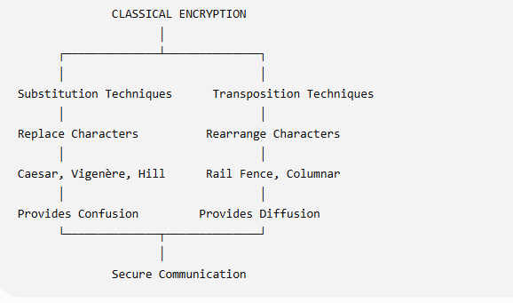

1. Substitution Technique
Definition
In substitution encryption, every plaintext character is replaced by another character using a key.
Examples
- Caesar Cipher
- Monoalphabetic Cipher
- Vigenère Cipher
- Hill Cipher
Example
Plaintext:
HELLO
Ciphertext (Caesar):
KHOOR
Effect: Characters change, but their positions remain the same.

2. Transposition Technique
Definition
In transposition encryption, the characters remain the same, but their positions are rearranged.
Examples
- Rail Fence Cipher
- Columnar Transposition Cipher
Example
Plaintext:
HELLO
Ciphertext:
LEHLO
Effect: Character positions change, but the letters remain the same.
Similarities
- Both are classical encryption methods.
- Both convert plaintext into ciphertext.
- Both use encryption keys.
- Both improve data confidentiality.
Differences
Feature | Substitution | Transposition
Method | Replaces characters | Rearranges characters
Characters | Changed | Unchanged
Position | Same | Changed
Principle | Confusion | Diffusion
Examples | Caesar, Hill | Rail Fence, Columnar

Effect on Data Structure
Data Structure
│
┌────┴────┐
│ │
Substitution Transposition
│ │
Characters Positions
Changed Changed
- Substitution: Changes the actual characters.
- Transposition: Changes only the order of characters.

Security Level
Technique | Security Level
Substitution | Medium to High
Transposition | Low to Medium

Which is More Vulnerable?
Transposition techniques are generally more vulnerable because:
- Original letters remain unchanged.
- Letter frequency is preserved.
- Rearrangement patterns can be analyzed by attackers.
Simple substitution methods like Caesar are also weak, but advanced substitution methods such as Vigenère and Hill Cipher provide better security than basic transposition techniques.

Real-World Applications
Technique | Example Application
Substitution | Historical military communication
Transposition | Secret handwritten messages

Conclusion
Substitution and transposition are the two main classical encryption techniques. Substitution changes the characters, while transposition changes their positions. Both improve confidentiality, but substitution techniques—especially Vigenère and Hill Cipher—offer better security. Transposition techniques are more vulnerable because they preserve the original characters, making them easier to analyze and attack.

Question 4
Concept Map Connecting Steganography Concepts: Data Hiding, Watermarking and Survivability
Tasks
- a. Show relationships between these concepts.
- b. Analyze how each contributes to secure communication.
- c. Include one real-world application for each.

Introduction
Steganography is the technique of hiding secret information inside a digital medium such as an image, audio, video, or text without revealing the existence of the message. Unlike cryptography, which encrypts the message, steganography conceals the message itself. The key concepts related to steganography are Data Hiding, Watermarking, and Survivability.

Concept Map

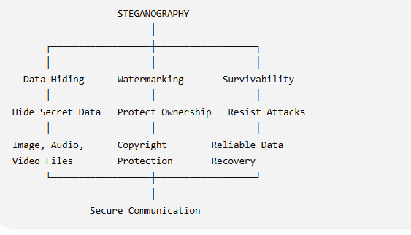
1. Data Hiding
Definition
Data hiding is the process of embedding secret information inside a cover medium such as an image, audio, or video without affecting its appearance.
Contribution to Secure Communication
- Keeps sensitive information hidden.
- Prevents unauthorized users from detecting the message.
- Improves confidentiality.
Real-World Application
- Military communication, where confidential messages are hidden inside digital images before transmission.

2. Watermarking
Definition
Watermarking is the process of embedding ownership or authentication information into digital content.
Contribution to Secure Communication
- Protects copyright.
- Verifies ownership of digital content.
- Prevents unauthorized copying.
Real-World Application
- Copyright protection for digital images, videos, and online documents.

3. Survivability
Definition
Survivability refers to the ability of hidden data or watermarks to remain intact even after modifications such as compression, cropping, or noise.
Contribution to Secure Communication
- Ensures hidden information can still be recovered.
- Increases reliability during data transmission.
- Protects against accidental or intentional modifications.
Real-World Application
- Digital watermarking used in television broadcasting, where the watermark remains even after video compression.

Relationship Between the Concepts
Concept | Relationship
Data Hiding | Conceals secret information inside a cover file.
Watermarking | Embeds ownership or authentication information.
Survivability | Ensures hidden data or watermarks remain intact after attacks or modifications.

How They Support Secure Communication
Secret Message
│
▼
Data Hiding
│
▼
Watermarking
│
▼
Survivability
│
▼
Secure and Reliable Communication

Comparison Table
Feature | Data Hiding | Watermarking | Survivability
Purpose | Hide secret information | Protect ownership | Preserve hidden data
Focus | Confidentiality | Copyright | Reliability
Medium | Image, Audio, Video | Digital Media | Any Watermarked Data
Example | Hidden message in an image | Company logo in videos | Watermark survives compression

Advantages
- Protects confidential information.
- Ensures copyright protection.
- Improves reliability of hidden information.
- Supports secure digital communication.

Conclusion
Steganography enhances secure communication by hiding information within digital media. Data Hiding conceals confidential messages, Watermarking protects ownership and authenticity, and Survivability ensures that the embedded information remains available even after modifications or attacks. Together, these techniques provide confidentiality, authenticity, and reliability, making them essential for modern digital security.

Question 5
Concept Map Linking Number Theory Concepts Used in Cryptography
Topics
- Modular Inverse
- Extended Euclidean Algorithm
- Fermat's Little Theorem
- Euler's Phi Function
- Euler's Theorem
Tasks
- a. Show how each concept is mathematically connected.
- b. Map their role in encryption and decryption.
- c. Analyze which concept is most critical for public key cryptography and justify.

Introduction
Number theory forms the mathematical foundation of modern cryptography. Algorithms such as RSA and Diffie–Hellman rely on concepts like modular arithmetic, modular inverse, Euler's theorem, and Fermat's Little Theorem for secure encryption and decryption.

Concept Map
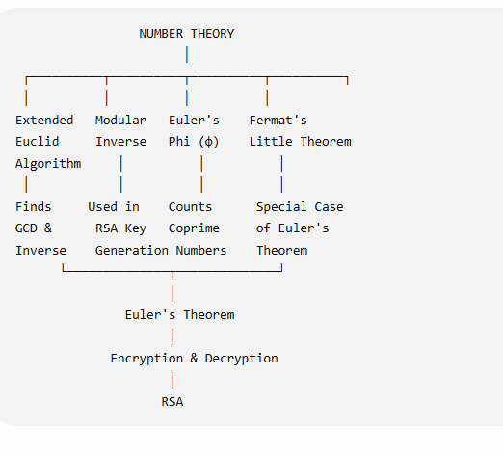

1. Extended Euclidean Algorithm
Definition
The Extended Euclidean Algorithm finds the Greatest Common Divisor (GCD) of two numbers and also computes the modular inverse.
Role in Cryptography
- Used to generate the private key in RSA.
- Computes the modular inverse needed for decryption.

2. Modular Inverse
Definition
A modular inverse of a number a is another number b such that:
[
a \times b \equiv 1 \pmod n
]
Role in Cryptography
- Used to calculate the RSA private key.
- Essential for the decryption process.

3. Euler's Phi Function (φ(n))
Definition
Euler's Phi Function gives the number of positive integers less than n that are relatively prime to n.
Example:
For n = 10
Numbers relatively prime to 10 are:
1, 3, 7, 9
Therefore,
[
\phi(10)=4
]
Role in Cryptography
- Used in RSA key generation.
- Helps calculate the private key.

4. Fermat's Little Theorem
Definition
If p is a prime number,
[
a^{p-1}\equiv1\pmod p
]
where a is not divisible by p.
Role in Cryptography
- Simplifies modular exponentiation.
- Used in primality testing.
- Supports RSA calculations.

5. Euler's Theorem
Definition
If a and n are coprime,
[
a^{\phi(n)}\equiv1\pmod n
]
Role in Cryptography
- Forms the mathematical basis of RSA.
- Ensures correct encryption and decryption.

Mathematical Connection
Extended Euclid
│
Find Modular Inverse
│
▼
Euler's Phi Function
│
▼
Euler's Theorem
│
▼
RSA Encryption/Decryption
▲
│
Fermat's Little Theorem

Role in Encryption and Decryption
Concept | Role
Extended Euclidean Algorithm | Computes modular inverse
Modular Inverse | Generates RSA private key
Euler's Phi Function | Used in RSA key generation
Fermat's Little Theorem | Supports modular arithmetic and primality testing
Euler's Theorem | Enables RSA encryption and decryption

Comparison Table
Concept | Main Purpose | Used In
Extended Euclidean Algorithm | Find GCD & modular inverse | RSA
Modular Inverse | Private key generation | RSA
Euler's Phi Function | Count coprime numbers | RSA
Fermat's Little Theorem | Modular arithmetic | Primality Testing, RSA
Euler's Theorem | Encryption & Decryption | RSA

Most Critical Concept for Public Key Cryptography
Euler's Theorem is the most critical concept because:
- It provides the mathematical foundation of the RSA algorithm.
- It guarantees that encrypted data can be correctly decrypted using the corresponding private key.
- It works together with Euler's Phi Function and Modular Inverse to generate secure RSA keys.
- Without Euler's Theorem, RSA encryption and decryption would not function correctly.

Real-World Applications
Concept | Application
Extended Euclidean Algorithm | RSA key generation
Modular Inverse | Digital signatures and RSA decryption
Euler's Phi Function | Public key generation
Fermat's Little Theorem | Prime number testing
Euler's Theorem | RSA encryption and secure communication

Conclusion
Number theory is the backbone of modern cryptography. The Extended Euclidean Algorithm computes modular inverses, Euler's Phi Function identifies coprime numbers, Fermat's Little Theorem supports modular arithmetic, and Euler's Theorem provides the mathematical basis for RSA encryption and decryption. Among these concepts, Euler's Theorem is the most important because it enables secure public-key cryptography and ensures the correctness of encryption and decryption operations.

